

**Artificial Intelligence and Data Science Department.**

OS / Even Sem 2021-22 / Experiment 3.

**___________________________________________________**

YASH SARANG.

47 / D6AD.

EXPERIMENT - 3.

SHELL SCRIPTS

**___________________________________________________**

**Aim:** Write shell scripts to do the following:

Display current shell, home directory, operating system type, current path setting, current working directory.

Display OS version, release number, kernel version.

**___________________________________________________**

**Theory:**

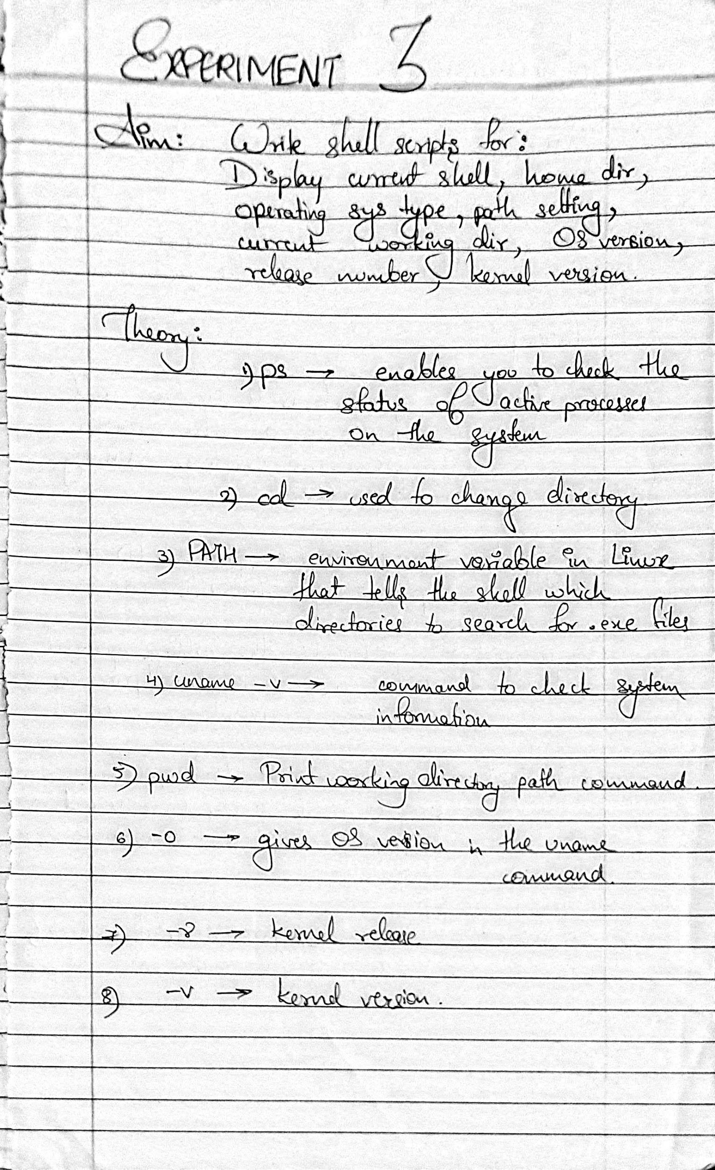

**___________________________________________________**

**Snippets:**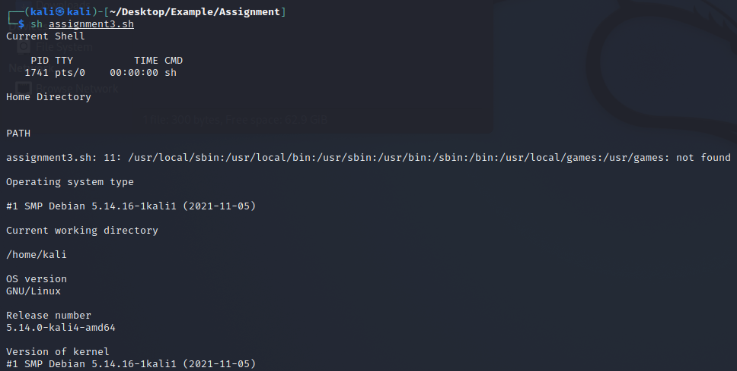

**___________________________________________________**

Conclusion:-

Thus we have learned to implement shell scripts in Unix.

**___________________________________________________**